Project Design Phase-II
Technology Stack (Architecture & Stack)
Date | 19 July 2026
Team ID | [Fill in your Team ID]
Project Name | Book A Doctor – Online Doctor Appointment Booking System
Maximum Marks | 4 Marks

Technical Architecture
Book A Doctor follows a classic 3-tier MERN architecture: a React single-page application (client tier), an Express.js REST API (application/logic tier), and MongoDB Atlas (data tier). The diagram below shows how a request flows from the browser through authentication, business logic, and into the database, along with the supporting services (email reminders, hosting).
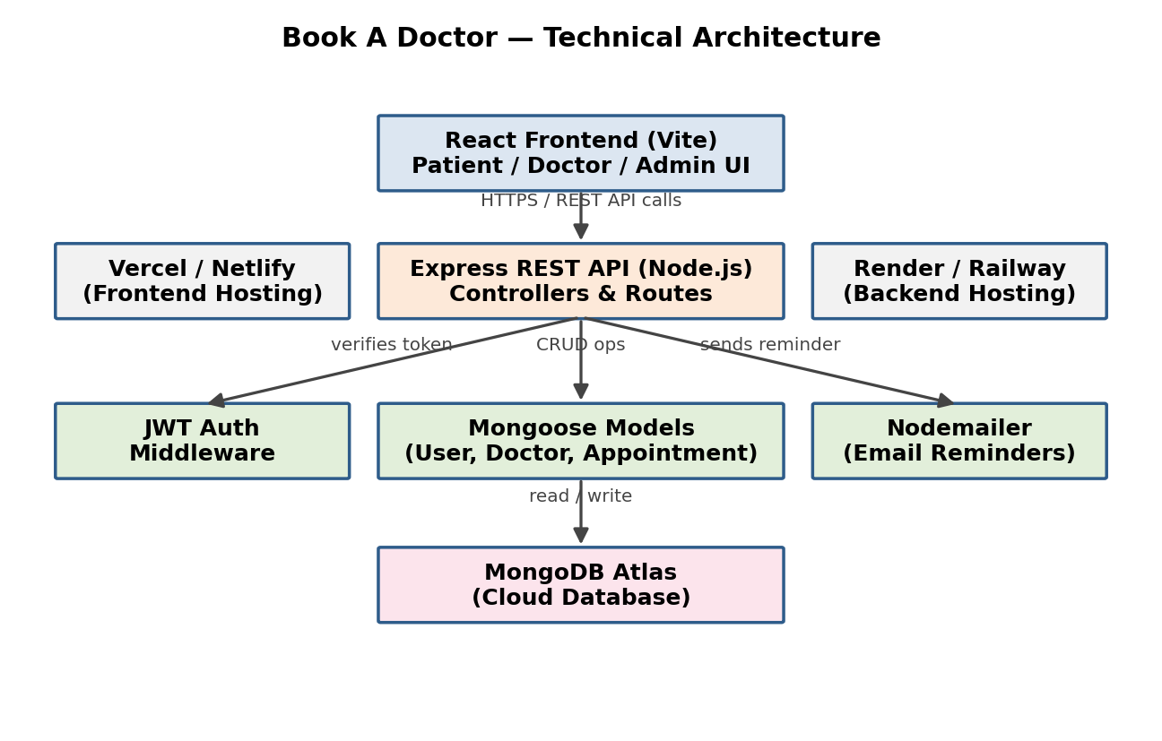
Table-1: Components & Technologies
S.No | Component | Description | Technology
1 | User Interface | How the user interacts with the application | React.js (Vite), HTML5, CSS3, Axios
2 | Application Logic-1 | Authentication & authorization | Node.js, Express.js, JSON Web Tokens (JWT), bcrypt
3 | Application Logic-2 | Appointment booking & scheduling logic | Node.js, Express.js, Mongoose
4 | Application Logic-3 | Doctor & admin dashboard logic | Node.js, Express.js REST controllers
5 | Database | Storing users, doctors, and appointment data | MongoDB (NoSQL, document-based)
6 | Cloud Database | Managed database hosting | MongoDB Atlas
7 | File Storage | Doctor profile photos / documents | Local filesystem (dev) / Cloudinary (production)
8 | External API-1 | Sending appointment confirmations & reminders | Nodemailer with SMTP (Gmail/SendGrid)
9 | External API-2 | Payment collection (future scope) | Razorpay / Stripe API
10 | Infrastructure (Server / Cloud) | Application deployment | Frontend: Vercel/Netlify · Backend: Render/Railway

Table-2: Application Characteristics
S.No | Characteristics | Description | Technology
1 | Open-Source Frameworks | Frameworks used across the stack | React.js, Express.js, Mongoose
2 | Security Implementations | Access control and data protection | JWT-based auth, bcrypt password hashing, CORS policy, input validation
3 | Scalable Architecture | 3-tier architecture separating UI, API, and data layers | React (client) + Express (server) + MongoDB (data)
4 | Availability | Keeping the app reachable with minimal downtime | Managed hosting (Render/Vercel) with automatic restarts
5 | Performance | Fast response and reduced load | MongoDB indexing on doctor/appointment fields, Axios caching on frontend

Why This Stack
The MERN stack was chosen because it uses a single language (JavaScript/TypeScript) across both frontend and backend, has a mature ecosystem for building REST APIs quickly, and MongoDB's flexible schema suits evolving data like doctor availability slots. All chosen tools are open-source or offer generous free tiers, keeping the project cost-effective for an academic/portfolio deployment.
If you have your own deployment diagrams, ER diagrams, or cloud console screenshots from your actual project, send them and I will insert them directly into this document in place of the generated architecture diagram above.

